Experiment 3 - Oscilloscope

Amirhossein Tayebi 810198430

Armin Eslami 810198349

Abstract— This document is about designing and implementing a oscilloscope using the Cyclone II board

Keywords—wrapper

1. Exponential Engine

The Verilog code of this testbench is shown in

Fig.1

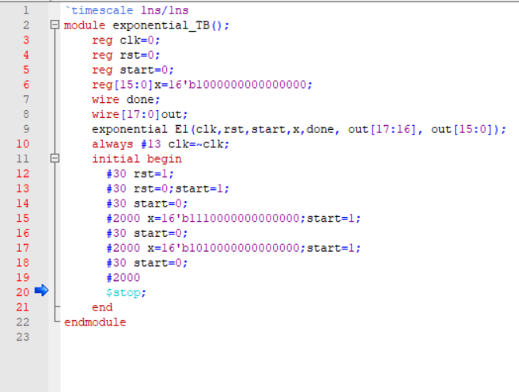

Fig. 1: The Verilog code of Accelerator testbench

The functionality test results are shown in fig.2, 3, 4, 5, 6 and 7.

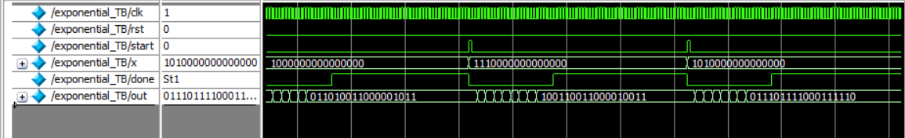

.

Figure .2: Test result of Fullwave sinus wave

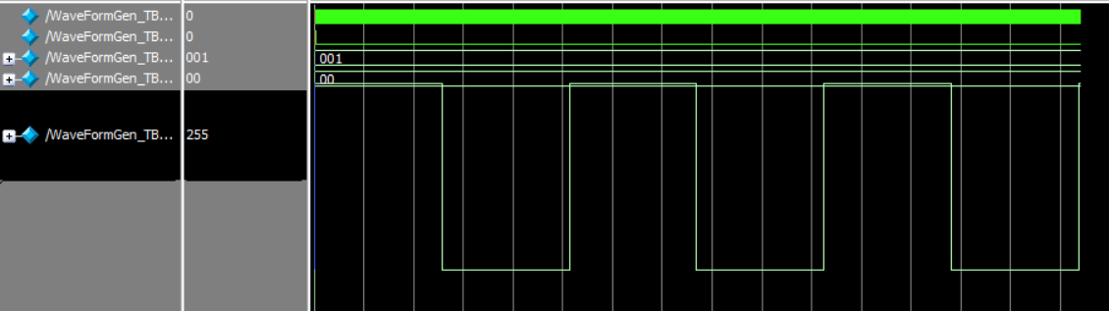

Figure. 3: test result of Rectangular wave

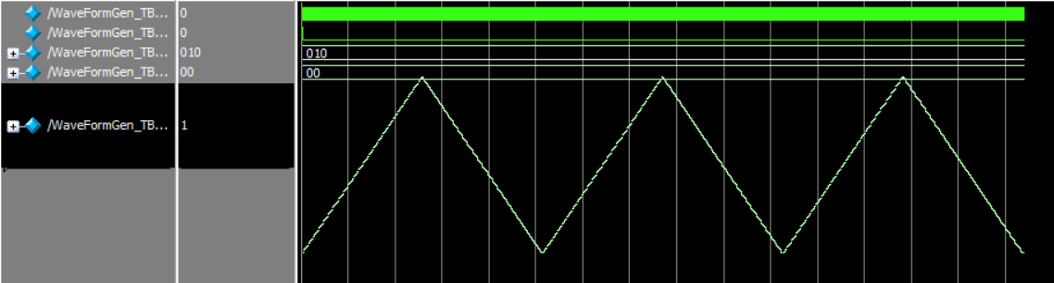

Fig.4: test result of triangular wave

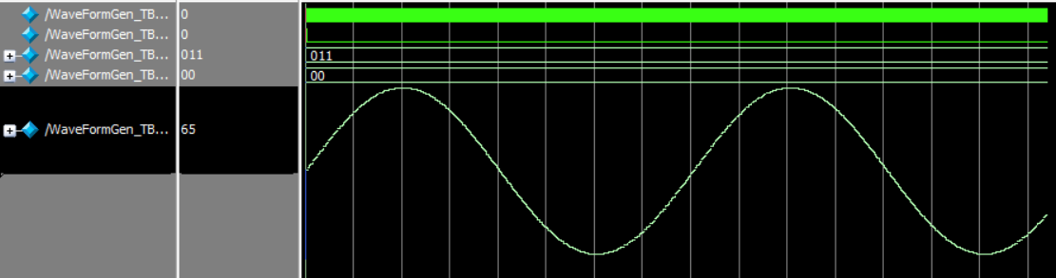

Fig.5: Test result of sinus wave

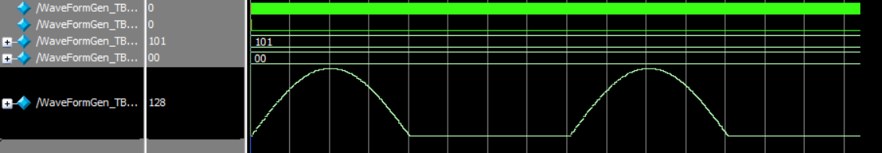

Fig.6: Test result of Halfwave sinus wave

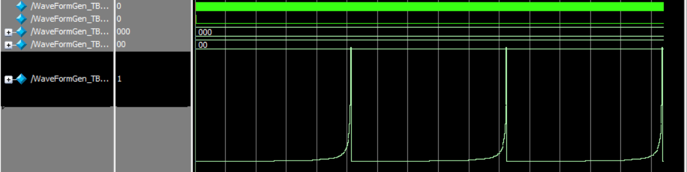

Fig.7: Test result of Reciprocal wave

1. Digital to Analog conversion using PWM

The Verilog code of PWM module is shown in fig.8.

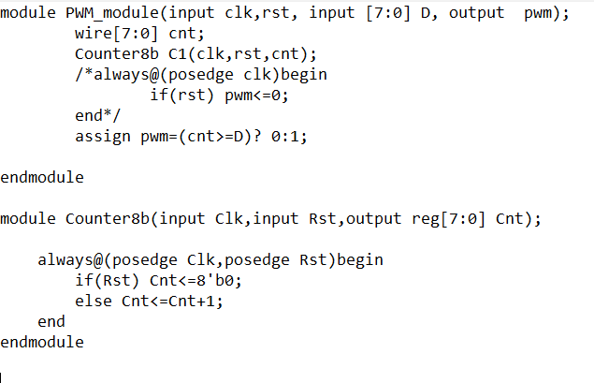

Fig.8: Verilog code of PWM module

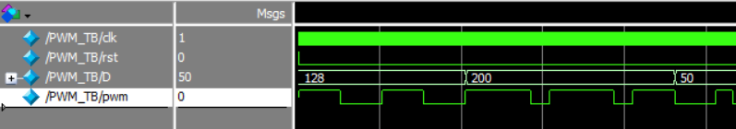

Fig.9: test result of PWM module

Because of the RC circuit, we see some time delays in actual implementations.